**Please complete the following items and submit by the assigned due date.**

**Algorithm Workbench *(2 pts each)***

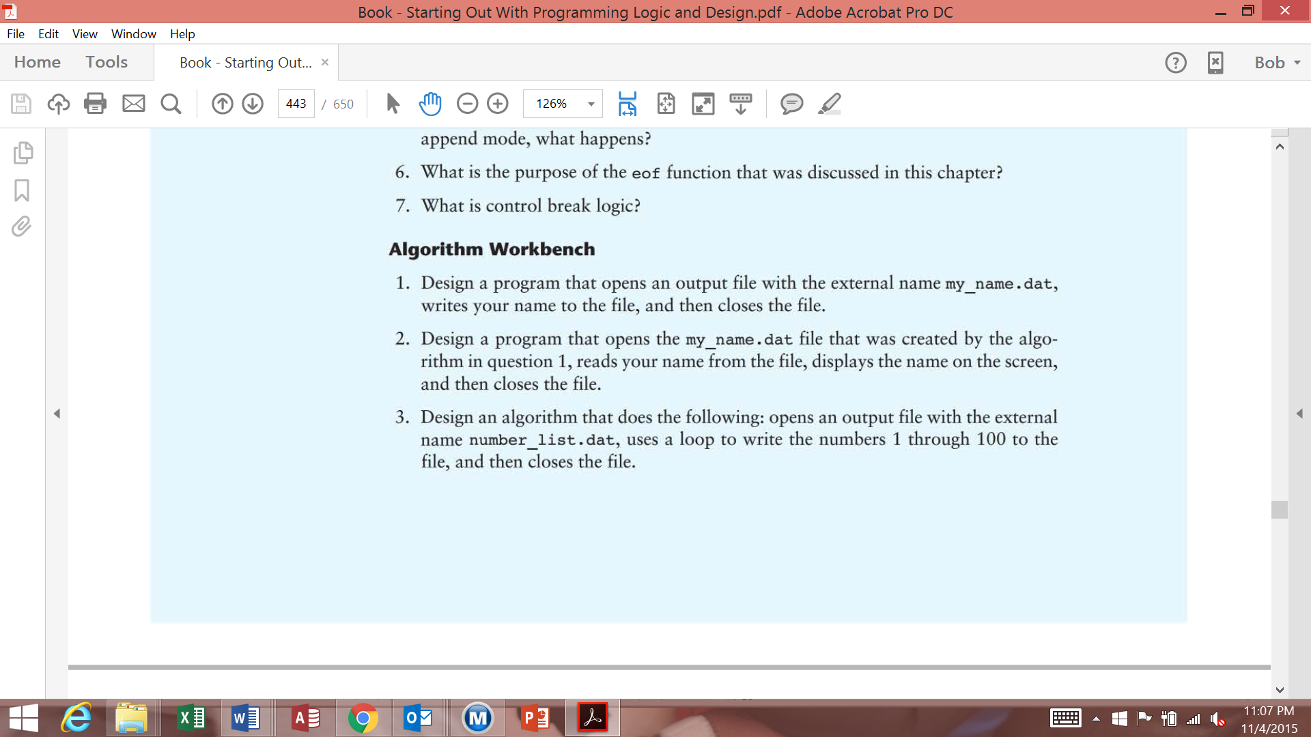

Declare OutputFile myFile

Open myFile(“number_list.dat”)

Declare Integer count

Set count = 1

While count <= 100

Write myFile count

Set count = count + 1

End While

Close myFile

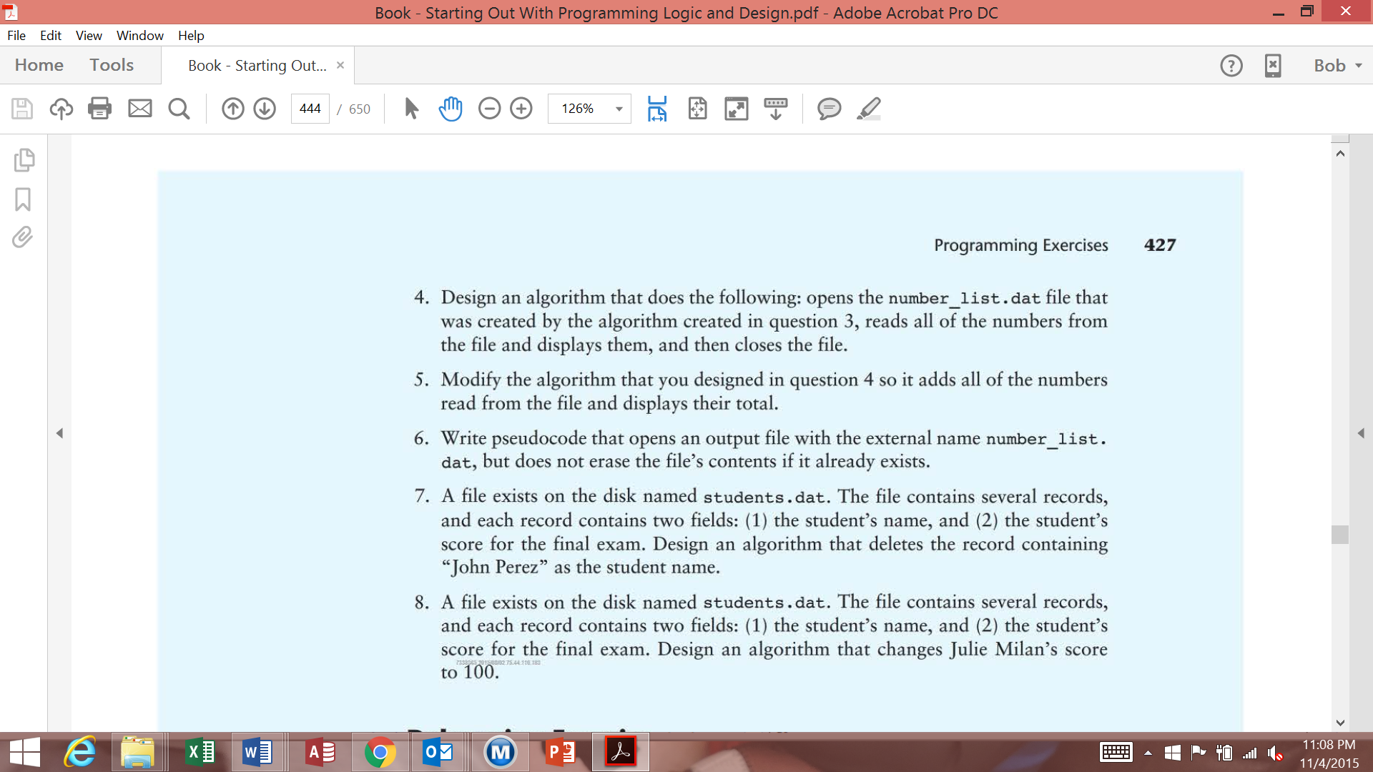

Declare InputFile myFile

Open myFile(“number_list.dat”)

Declare Integer num

While NOT eof(myFile)

Read myFile num

Display num

End While

Close myFile

**Debugging Exercises: *(4 pts)***

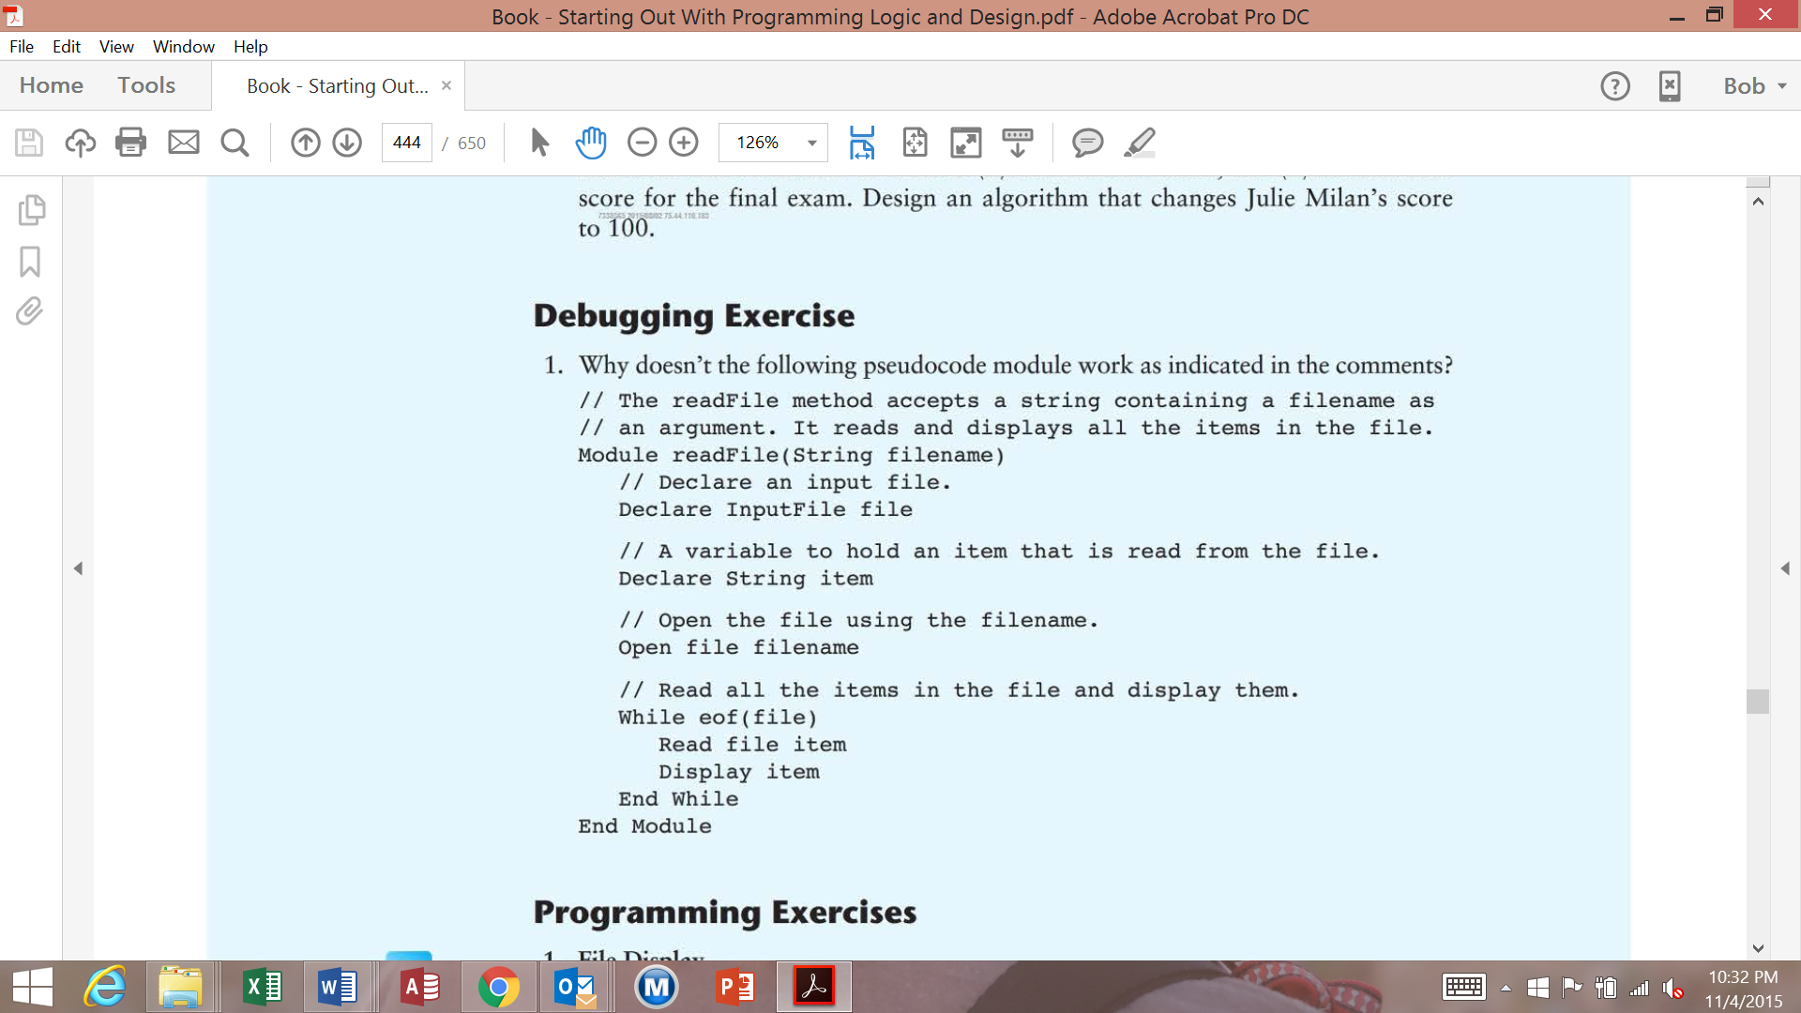

The “While eof(file)” loops needs to read “While NOT eof(file)”

There also needs to be an argument closing the file called into question, i.e: Close file filename

**Programming Exercises: *( 8 pts pseudocode, 9 pts flowchart)***

***\*\*\* PLUS – You can earn an extra 5 pts Extra Credit for the Python code***

**Write a program that will do the following:**

1. Read the file “numbers.txt” (which is provided in the assignment, so you must download it and place it in a location on your disc for your program to use.
2. Using the data from “numbers.txt” (and the selection sort from chapter 9), sort the data in ascending order.
3. Append the sorted information to the “numbers.txt” file and write the file back to disk.

**HINTS:**

1. Since you are using the data, but appending the sorted data back to the original file, you are “DOUBLING” the size of the document.
2. Since you are appending the data, before you run your program, you must copy the “numbers.txt” back to your hard drive to start over, otherwise you file will double in size each time you run the program.

Declare InputFile homeworkFile

Declare Integer count

Declare Constant size = 49

Declare Integer fileValue

Set count = 0

Declare Integer fileArray[count]

Open homeworkFile(“numbers.txt”)

While NOT eof(homeworkFile)

Read homeworkFile fileValue

Set fileArray[count] = fileValue

Set count = count + 1

End While

Close homeworkFile

Set count = count - 1

Call selectionSort(fileArray[])

Call writeAppend(size, fileArray[], count)

//

//-----------------------------------------------------------------------

//

Module selectionSort(fileArray[])

Declare Integer minIndex

Declare Integer index

Declare Integer minValue

Declare Integer startScan

Set startScan = 0

Set index = 0

While NOT startScan > size

Set minIndex = startScan

Set minValue = fileArray[startScan]

While NOT index > size

If fileArray[index] < minValue

Set minValue = fileArray[index]

Set minIndex = index

End If

Set index = index + 1

End While

Call swap(fileArray[], minIndex, startScan)

Set startScan = startScan + 1

End While

Return fileArray[]

End Module

//

//----------------------------------------------------------------------------

//

Module writeAppend(size, fileArray[], count)

Declare OutputFile AppendMode homeworkFile

Open homeworkFile (“numbers.txt”)

Set count = 0

While NOT eof(homeworkFile)

Write homeworkFile fileArray[count]

Set count = count + 1

End While

Close homeworkFile

End Module

//

//--------------------------------------------------------------------------

//

Module swap(fileArray[], minIndex, startScan)

Declare Integer temp

Set temp = fileArray[minIndex]

Set fileArray[minIndex] = fileArray[startScan]

Set fileArray[startScan] = temp

End Module